Systems Analysis and Design
Phase 1 Use Case Diagram
A00051090
Mattia Contestabile

Use Case Diagram illustrating the interactions between the system actors and the available use cases.
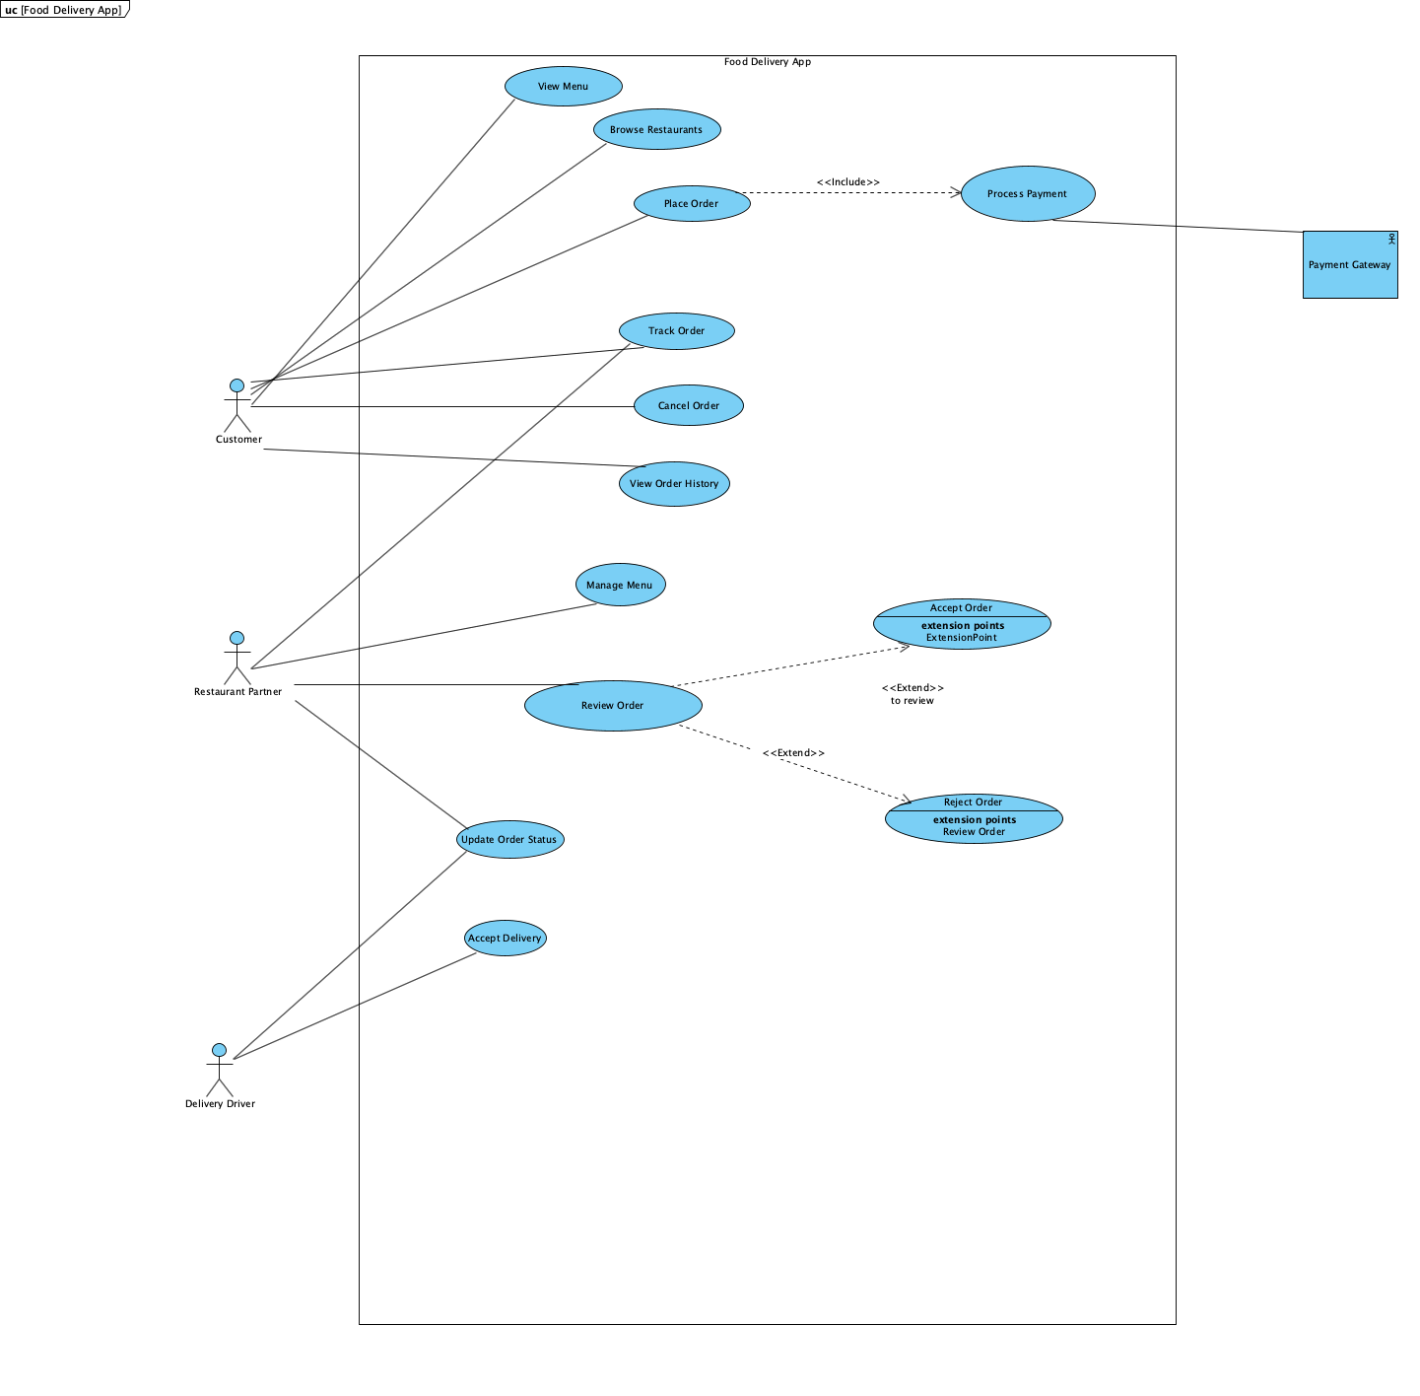

This Use Case Diagram depicts the 3 actors:
- Customer
- Restaurant Manager
- Delivery Driver
- Payment Gateway

The Customer actor interacts with the system to perform the main food delivery app functionalities such as browsing restaurants, browsing menus, placing orders, processing payment through the Payment Gateway, tracking orders, cancelling orders, and then viewing order history. This set of actions represents the core functionalities available to the customer when using the food delivery app.

The Restaurant Partner also interacts with the system to perform operational features, some of which are shared with the customer. These include tracking orders and reviewing incoming orders. When reviewing an order, the restaurant partner can decide to either accept or reject an order if unable to fulfil it. Another core feature the restaurant partner has access to is updating order status through the system. This feature will be extensively used by both the restaurant partner and the delivery driver.

The Delivery Driver interacts with the system by receiving delivery requests and deciding whether to accept or reject them. Once a delivery has been accepted, the system updates the order status to reflect the delivery driver's progress.

The Payment Gateway is an external entity not governed by the food delivery app that will handle the payment by letting the customer choose their favorite payment method and transferring the funds to the food delivery app in order to complete the checkout process.

